**A Generic Model To Analyze And Predict Brain Tumor From MRI And CT Medical Images Using Deep Learning**

In this project we are using brain tumor MRI images to build deep learning auto stack CNN model. To implement this project we are using following modules.

1. Upload MRI image: using this module we are uploading MRI train images and then application read all images and convert them grey format.
2. OSTU Thresholding: Using this module we will apply OSTU thresholding technique on each image to extract features.
3. Generate Train & Test Model: Using this module we will build array of pixels with all images features and then split dataset into train and test model to calculate accuracy using test images by applying train model on it.
4. Generate Deep Learning CNN Model: Using this module will input train and test data to auto stack CNN model to build training classifier.
5. Get DriveHQ Images: Using this module we will read test image from DriveHQ website and then application will apply CNN classifier model on that test image to predict whether image contains tumour disease or not.

Actually student wants to read all images from DriveHQ but it will take lots of time to read from DriveHQ using internet as train data contains nearly 260 images. So I put some test image on DriveHQ while testing CNN model you can read images from DriveHQ and predict tumour.

Below screen showing some images saved at DriveHQ

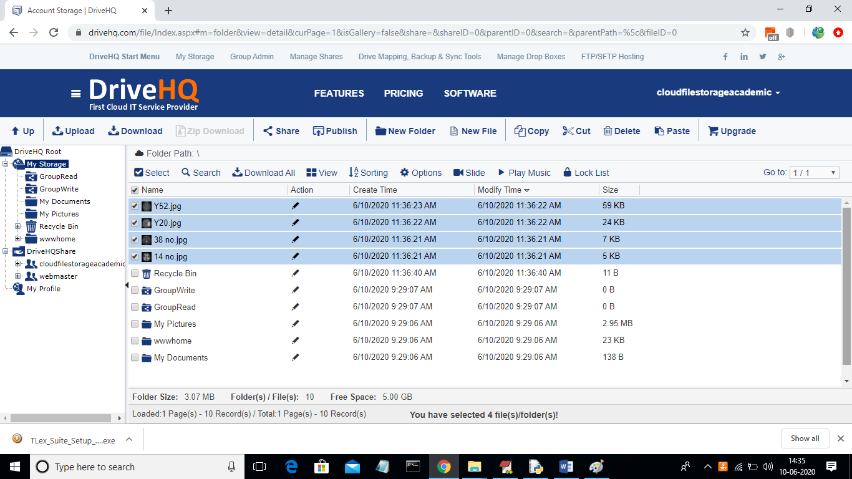

In above DriveHQ screen we can see some brain MRI images are stored and application will download from here. If you want you can also upload few images in above screen and then application will read new images also.

To run project double click on ‘run.bat’ file to get below screen

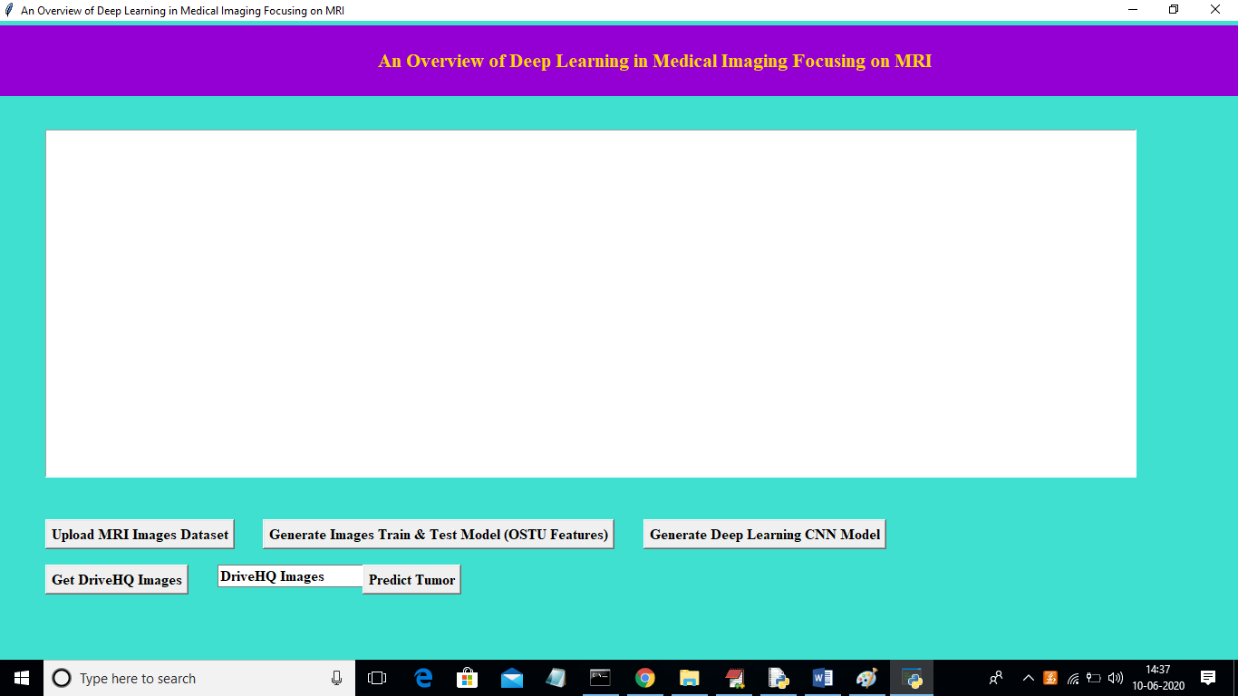

In above screen click on ‘Upload MRI Images Dataset’ button and upload images directory

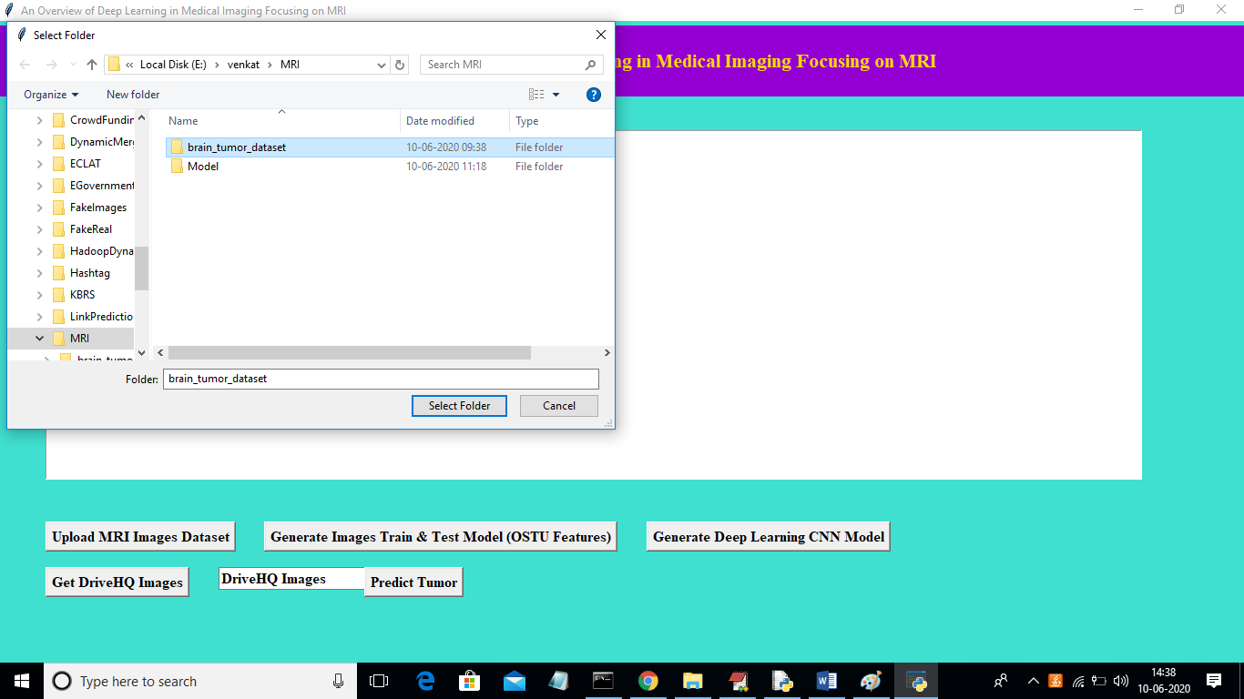

In above screen I am uploading complete folder called ‘brain_tumor_dataset’ which contains images with and without tumour. Now click on ‘Select Folder’ button to get below screen.

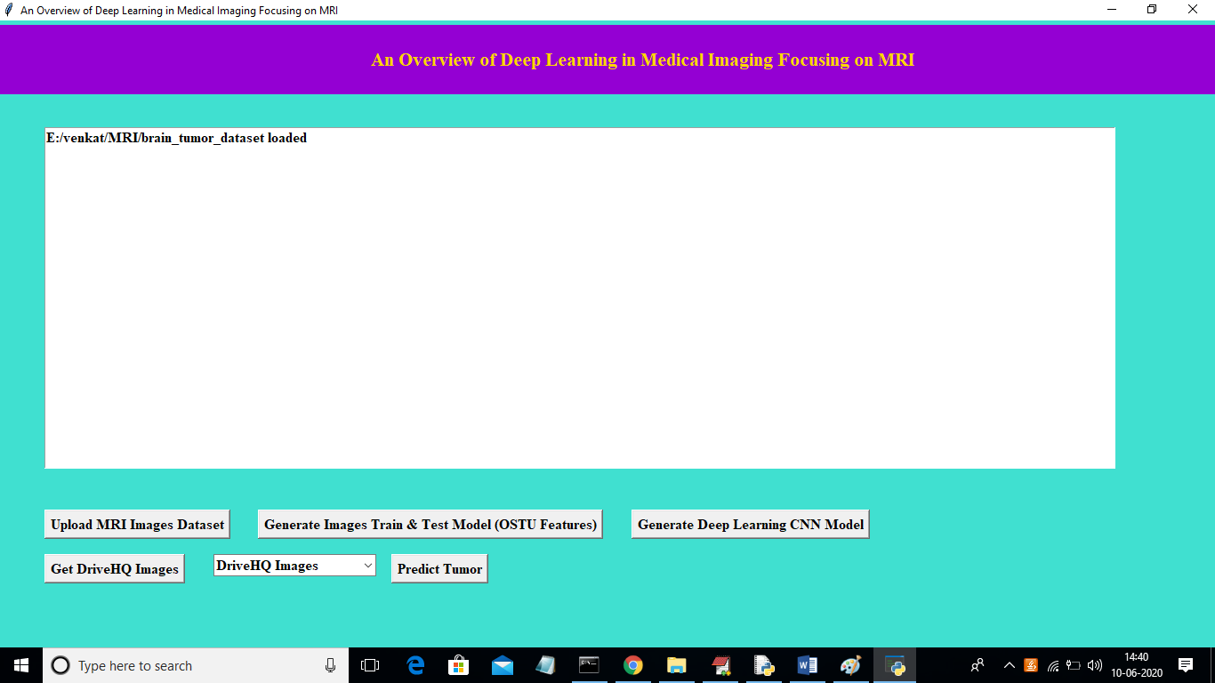

In above screen click on ‘Generate Images Train & Test Model (OSTU Features)’ button to read images and then extract features using OSTU and then build train and test model

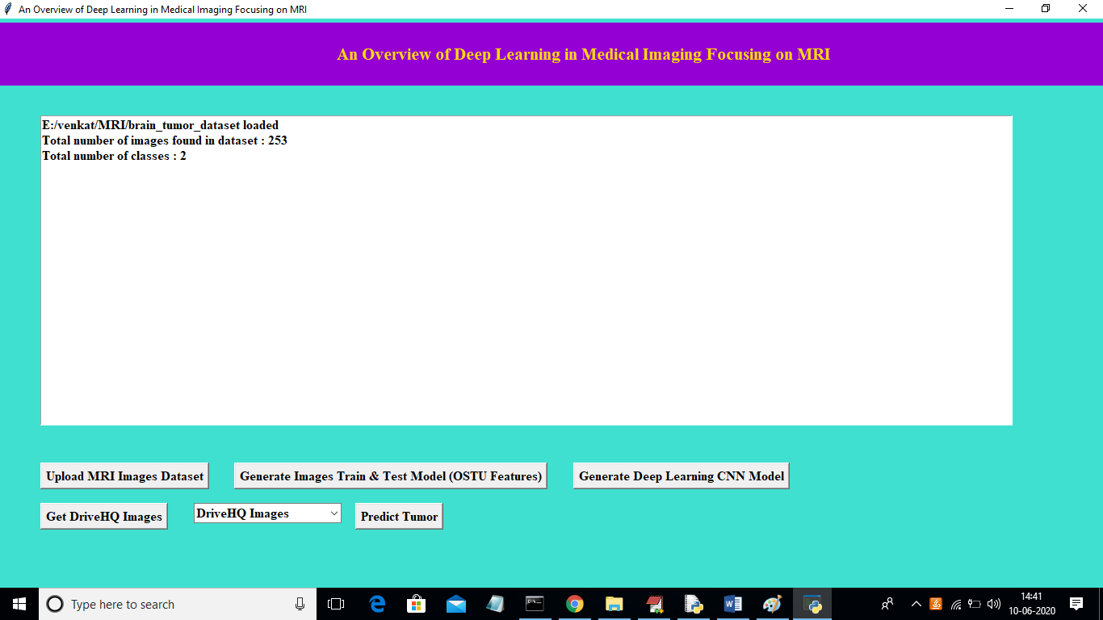

In above screen we can see dataset contains total 253 images and those images belongs to 2 classes called ‘yes’ or ‘no’. yes means tumour is there and no means no tumour. Now click on ‘Generate Deep Learning CNN Model’ button to generate CNN classifier.

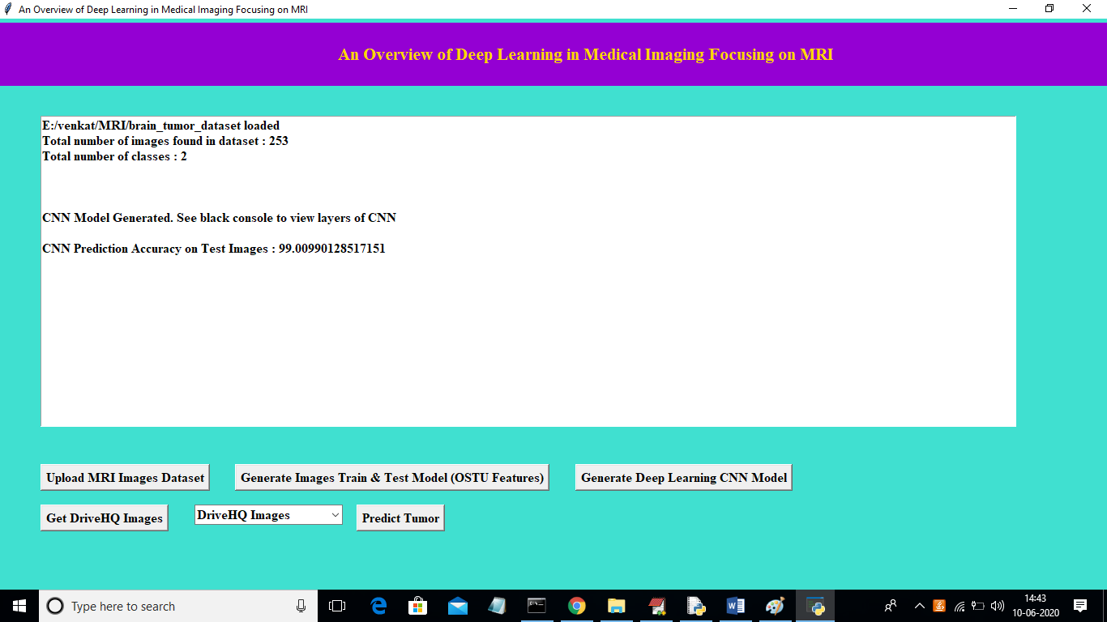

In above screen we got CNN test images prediction accuracy as ’99.009%’ and we can see below black console to see CNN layer details

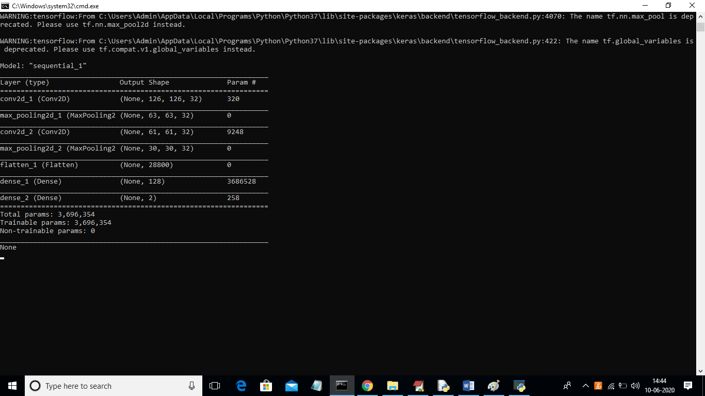

In above screen auto stack CNN using 4 layers to build filter CNN classifier with 4 different images size. First layer built using 126 X 126 image size and second with 63 and goes on. With this layer we got 99% accuracy. In below screen we have DriveHQ drop down box with no image names

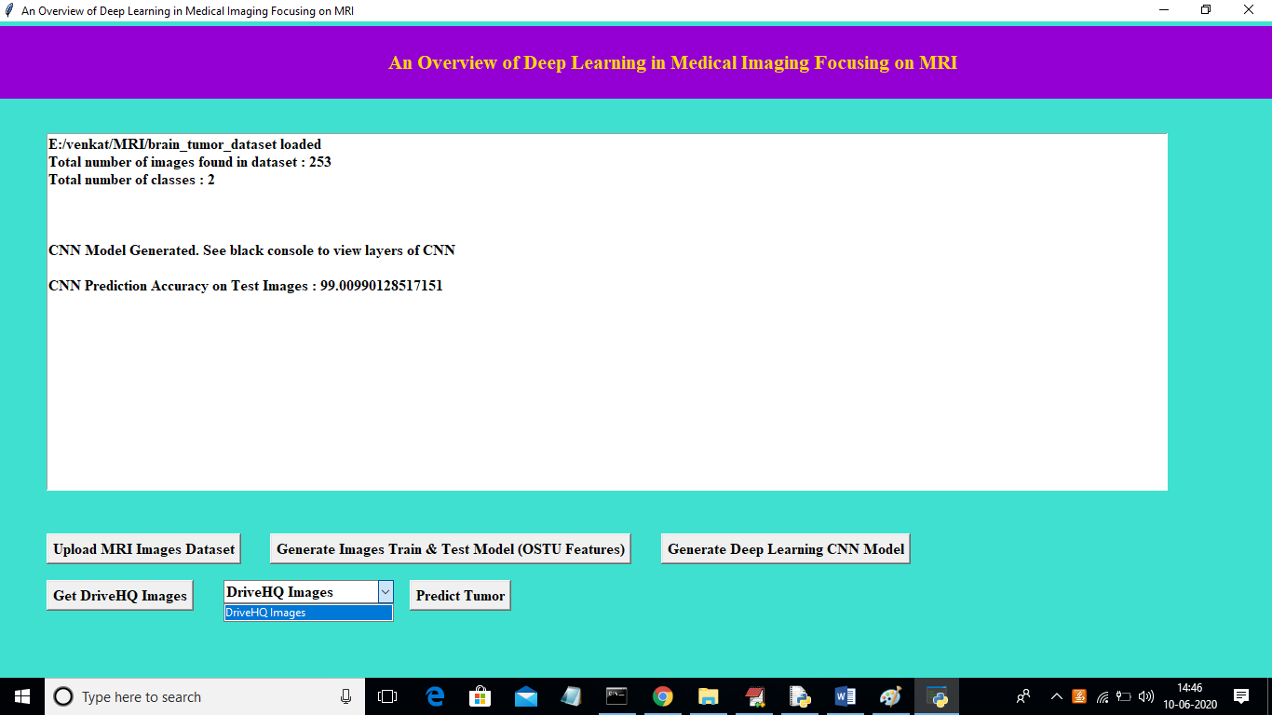

In above screen in DriveHQ Images drop down box there are no images and to read available images from DriveHQ click on ‘Get DriveHQ Images’ button. After clicking that button we can see all images names from DriveHQ will display in drop down box and then we can select any image and click on ‘Predict Tumor’ button to predict disease.

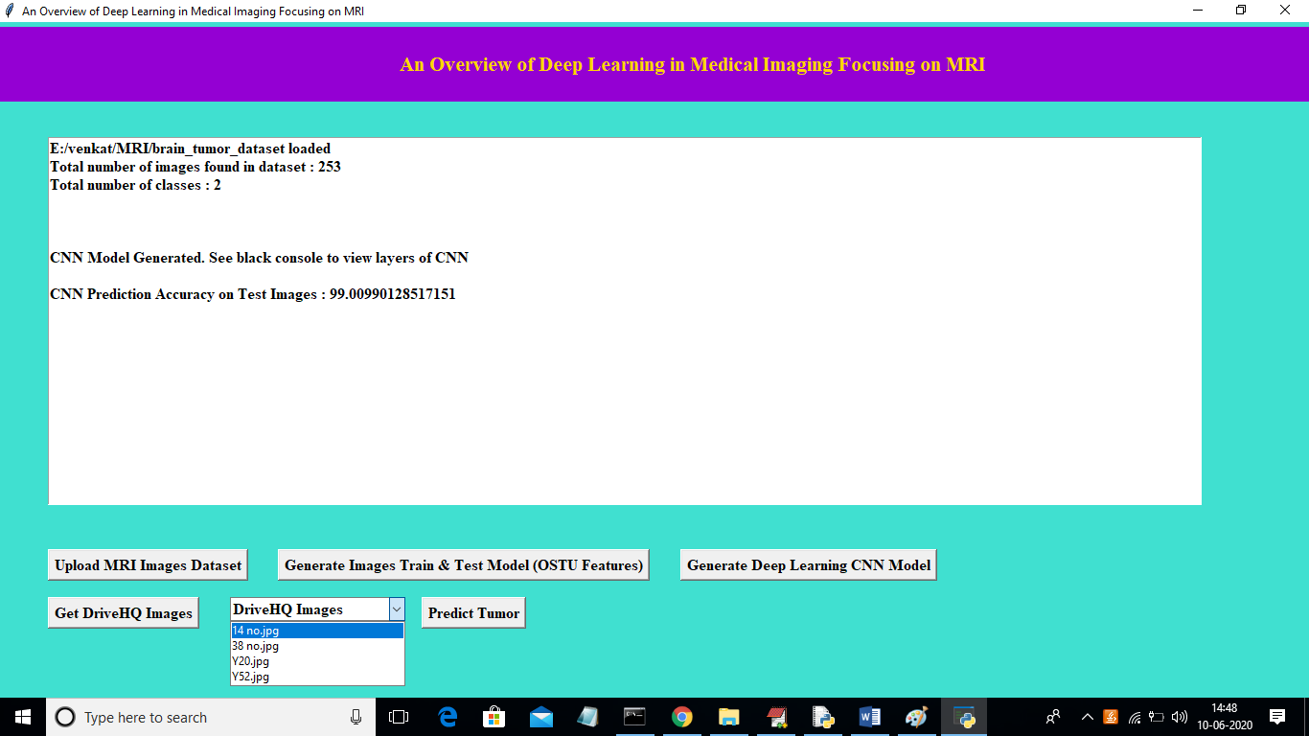

In above screen we can see all images list displaying in drop down box from DriveHQ and then select any image and click on ‘Predict Tumour’ button

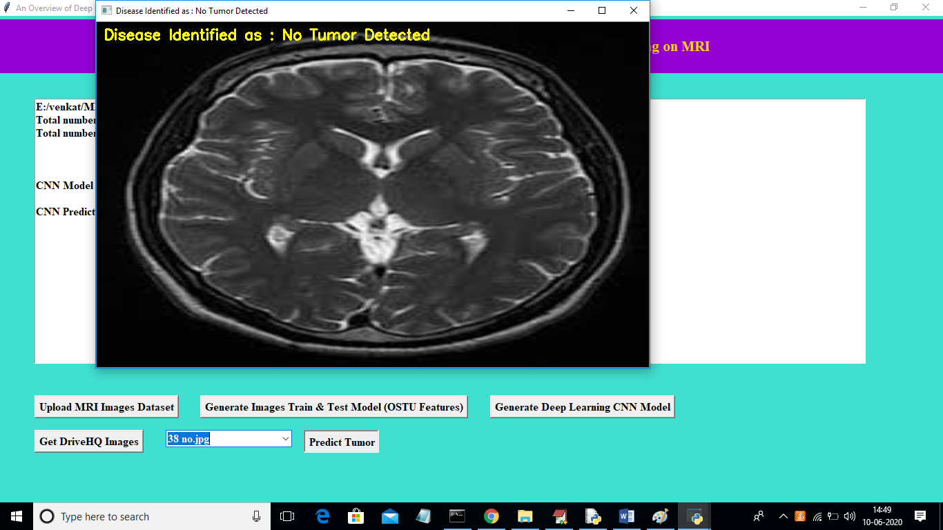

In above screen from drop down box I selected images as ’38 no.jpg’ and then application download that image from DriveHQ and then apply CNN classifier to predict tumour. In above image we can see predicted result as ‘No Tumor Detected’. Now I will upload another image and test

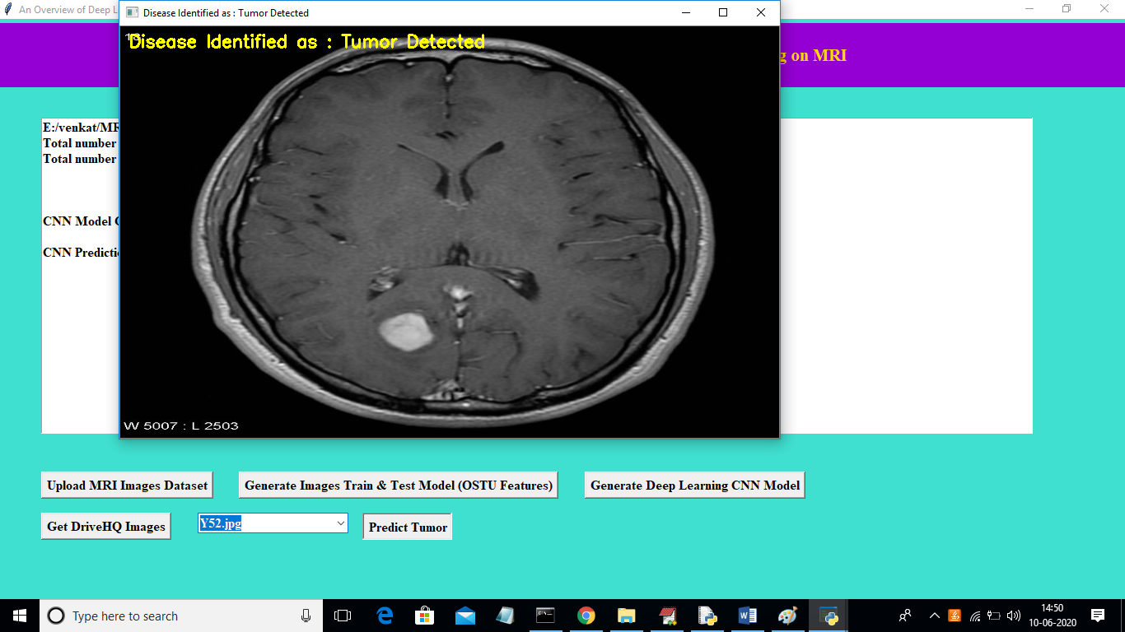

In above screen from drop down box I selected image as ‘Y52.jpg’ and its predicted disease as ‘Tumor Detected’. Similarly you can upload any MRI images on DriveHQ and perform prediction